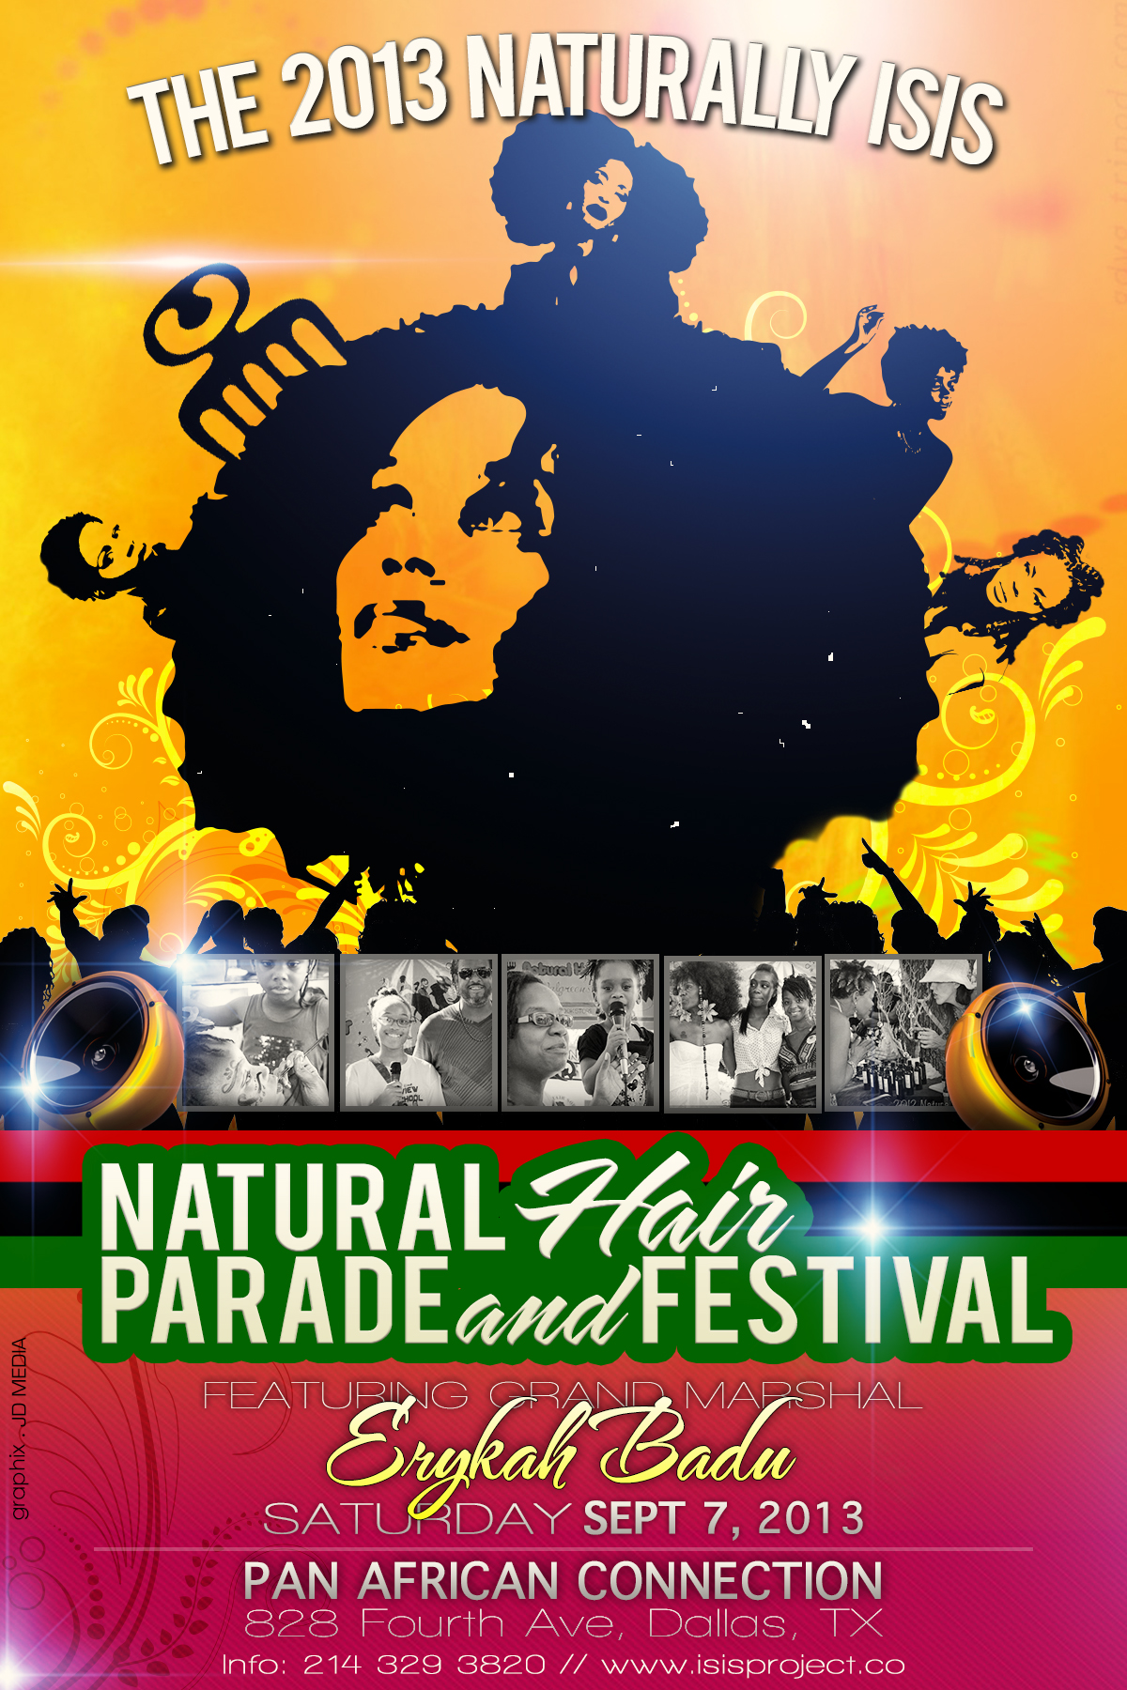

Greetings Everyone!!
On Saturday, Sept 7, 2013 from 10am-7pm, The Isis Project will host The 3rd Annual Naturally Isis
Natural Hair Parade and Festival and we would like you to become a part of this beautiful event. Our Commemorative Program book will feature, in various sizes, special words of our sponsors, volunteers, and visitors of the glorious event. By purchasing a space below, the name of your company will reach thousands, boast your customer base, as well as donate to the nonprofit scholarship fund provided by The Isis Project.
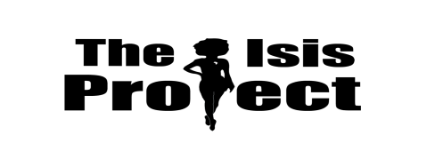
The 2013 Naturally Isis
3rd Annual Natural Hair Parade and Festival
Saturday, September 7, 2013
10am-7pm

All funds received will be used to further the Lewis and Woods Scholarship Foundation

To purchase an ad space, please select one of the options below:

_______Full Page Ad $100 *Color Ad add $10*
_______1/2 Page Ad $60
_______1/4 Page Ad $35
_______Patron List (Name Only) $15

Deadline for Submitting Advertisements-Friday, August 23, 2013

Statement of Commitment/Release

I, the undersigned, agree to pay the sum of $___________ for a _________page advertisement. I give my permission to have my photo/art/ad copied and placed in the souvenir directory for the 3rd Annual Natural Hair Parade and Festival c/o The Isis Project and Naturally Isis.

Contributor’s Information:
Name: ____________________________ Company Name: _________________

Signature: _________________________ Date: __________________________

Donation Amt:_____________________ Date: __________________________

Telephone: ___________________________ Fax: ________________________

If you would like to use your business card as an advertisement please include it with your pmt. Thanks!

I would like my ad to read:

Make your pmt through PayPal to:
naturallyisis@yahoo.com
Isis Brantley of Naturally Isis,
2642 S. Beckley Ave.
Dallas, TX 75224
.

